Batch: B1 Roll No.: 1711072

Experiment / assignment / tutorial No. 2

Grade: AA / AB / BB / BC / CC / CD /DD

Signature of the Staff In-charge with date

Title: Study of motherboard , chip set and CMOS

AIM : To study and understand a design of motherboard ,chipset and CMOS.

_____________________________________________________________________
Expected OUTCOME of Experiment:

CO 1: To study different Hardware components of the system and its importance.
_____________________________________________________________________
Books/ Journals/ Websites referred:

- IBM- PC BY Govindrajalu, THM
_____________________________________________________________________
Pre Lab/ Prior Concepts:

A motherboard is the main printed circuit board (PCB) found in general purpose microcomputers and other expandable systems. It holds and allows communication between many of the crucial electronic components of a system, such as the central processing unit(CPU) and memory, and provides connectors for other peripherals. Unlike a backplane, a motherboard usually contains significant sub-systems such as the central processor, the chipset's input/output and memory controllers, interface connectors, and other components integrated for general purpose use.
Motherboard specifically refers to a PCB with expansion capability and as the name suggests, this board is often referred to as the "mother" of all components attached to it, which often include peripherals, interface cards, and daughtercards: sound cards, video cards,network cards, hard drives, or other forms of persistent storage; TV tuner cards, cards providing extra USB or FireWire slots and a variety of other custom components.
Each motherboard is different. They can be different in design, size, shape, capabilities and configuration possibilities. Some may look the same and have subtle differences. These differences are dependent upon the form factor and manufacturer. Back in the early days of the industry, when computers were first beginning to be introduced in the market, there were very few differences and actually very few motherboards available.
Motherboard Components:
The main printed circuit board in a computer is known as the motherboard. Other names for this central computer unit are system board, mainboard, or printed wired board (PWB). The motherboard is sometimes shortened to Mobo.
Numerous major components, crucial for the functioning of the computer, are attached to the motherboard. These include the processor, memory, and expansion slots. The motherboard connects directly or indirectly to every part of the PC.
The type of motherboard installed in a PC has a great effect on a computer's system speed and expansion capabilities.
It’s like the air-traffic controller of a computer.

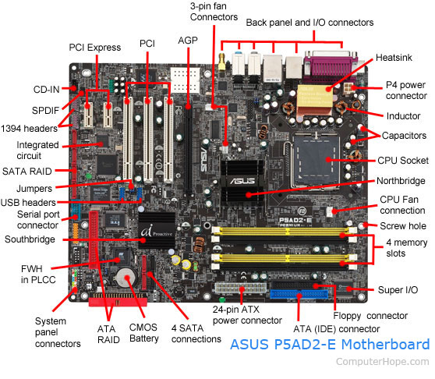

Microprocessor
Also known as the microprocessor or the processor, the CPU is the computer's brain. It is responsible for fetching, decoding, and executing program instructions as well as performing mathematical and logical calculations.
The processor chip is identified by the processor type and the manufacturer. This information is usually inscribed on the chip itself. For example, Intel 386, Advanced Micro Devices (AMD) 386, Cyrix 486, Pentium MMX, Intel Core 2Duo, or iCore7.
If the processor chip is not on the motherboard, you can identify the processor socket as socket 1 to Socket 8, LGA 775 among others. This can help you identify the processor that fits in the socket. For example, a 486DX processor fits into Socket 3.
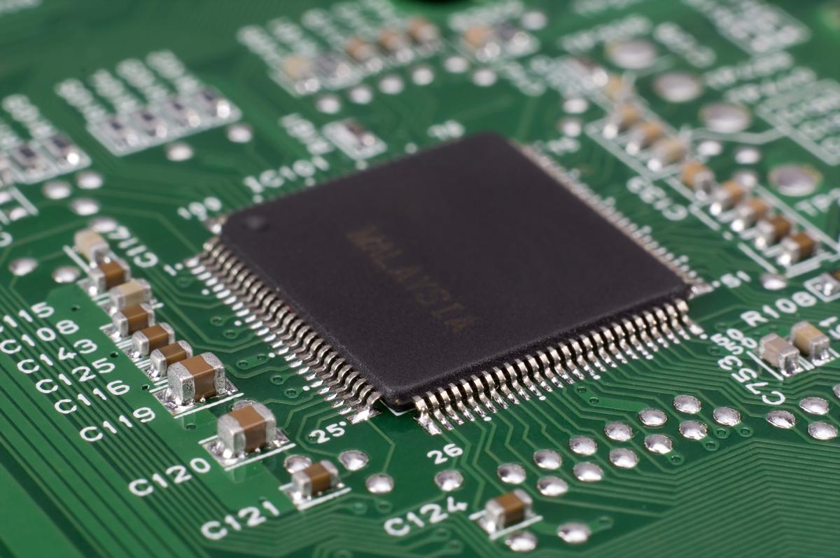

RAM

Random Access Memory, or RAM, usually refers to computer chips that temporarily store dynamic data to enhance computer performance while you are working.
In other words, it is the working place of your computer, where active programs and data are loaded so that any time the processor requires them, it doesn't have to fetch them from the hard disk.Random access memory is volatile, meaning it loses its contents once power is turned off. This is different from non-volatile memory, such as hard disks and flash memory, which do not require a power source to retain data.
When a computer shuts down properly, all data located in RAM is returned back to permanent storage on the hard drive or flash drive. At the next boot-up, RAM begins to fill with programs automatically loaded at startup, a process called booting. Later on, the user opens other files and programs that are still loaded in the memory
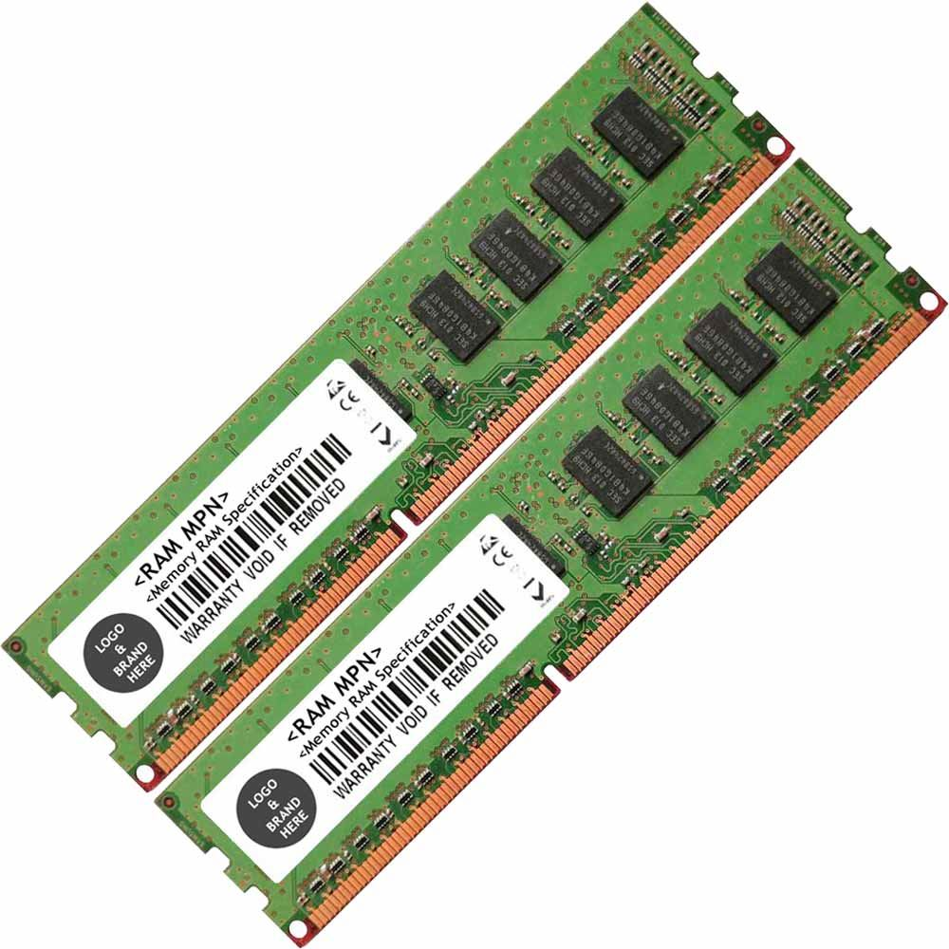

The BIOS
BIOS stands for Basic Input / Output System. BIOS is a "read-only" memory, which consists of low-level software that controls the system hardware and acts as an interface between the operating system and the hardware. Most people know the term BIOS by another name—device drivers, or just drivers. BIOS is essentially the link between the computer hardware and software in a system.
All motherboards include a small block of Read Only Memory (ROM) which is separate from the main system memory used for loading and running software. On PCs, the BIOS contains all the code required to control the keyboard, display screen, disk drives, serial communications, and a number of miscellaneous functions.
The system BIOS is a ROM chip on the motherboard used during the startup routine (boot process) to check out the system and prepare to run the hardware. The BIOS is stored on a ROM chip because ROM retains information even when no power is being supplied to the computer.

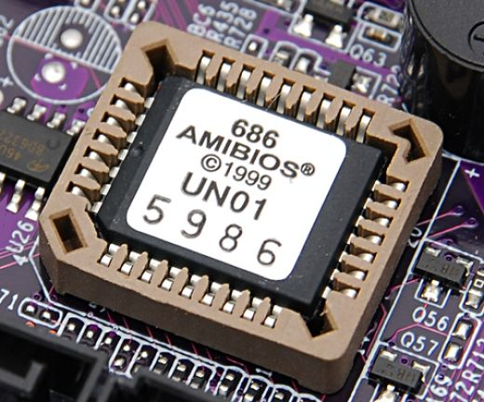

CMOS
CMOS stands for COMPLIMENTARY METAL OXIDE SEMICONDUCTOR
Motherboards also include a small separate block of memory made from CMOS RAM chips which are kept alive by a battery (known as a CMOS battery) even when the PC’s power is off. This prevents reconfiguration when the PC is powered on.
CMOS devices require very little power to operate.
The CMOS RAM is used to store basic Information about the PC’s configuration for instance:-
- Floppy disk and hard disk drive types
- Information about CPU
- RAM size
- Date and time
- Serial and parallel port information
- Plug and Play information
- Power Saving settings
Other Important data kept in CMOS memory is the time and date, which is updated by a Real Time Clock (RTC).

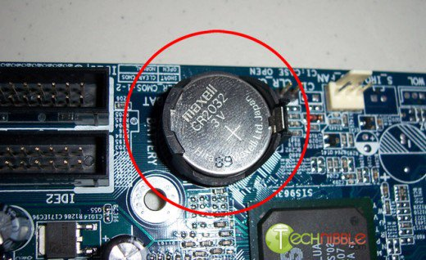

The Computer Cache Memory
Cache memory is a small block of high-speed memory (RAM) that enhances PC performance by pre-loading information from the (relatively slow) main memory and passing it to the processor on demand.
Most CPUs have an internal cache memory (built into the processor) which is referred to as Level 1 or primary cache memory. This can be supplemented by external cache memory fitted on the motherboard. This is the Level 2 or secondary cache.
In modern computers, Levels 1 and 2 cache memory are built into the processor die. If a third cache is implemented outside the die, it is referred to as the Level 3 (L3) cache.

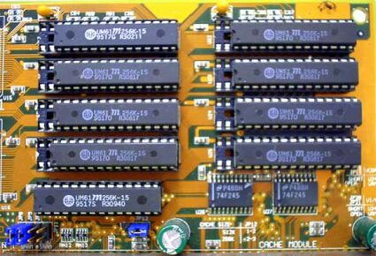

The Expansion Buses

An expansion bus is an input/output pathway from the CPU to peripheral devices and it is typically made up of a series of slots on the motherboard. Expansion boards (cards) plug into the bus. PCI is the most common expansion bus in a PC and other hardware platforms. Buses carry signals such as data, memory addresses, power, and control signals from component to component. Other types of buses include ISA and EISA.
Expansion buses enhance the PCs capabilities by allowing users to add missing features in their computers by slotting adapter cards into expansion slots.

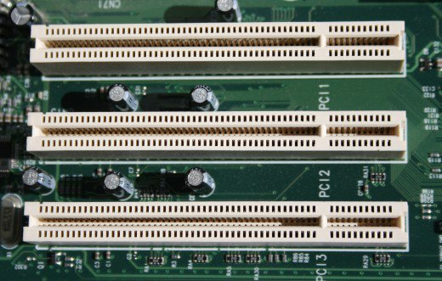

The Computer Chip-sets

A chipset is a group of small circuits that coordinate the flow of data to and from a PC's key components. These key components include the CPU itself, the main memory, the secondary cache, and any devices situated on the buses. A chipset also controls data flow to and from hard disks and other devices connected to the IDE channels.
A computer has got two main chipsets:
- The North Bridge (also called the memory controller) is in charge of controlling transfers between the processor and the RAM, which is why it is located physically near the processor. It is sometimes called the GMCH, for Graphic and Memory Controller Hub.

- The South Bridge (also called the input/output controller or expansion controller) handles communications between slower peripheral devices. It is also called the ICH (I/O Controller Hub). The term "bridge" is generally used to designate a component which connects two buses.
Chipset manufacturers include SIS, VIA, ALI, and OPTI.
North Bridge:
Alternatively, referred to as the PAC (PCI/AGP Controller) and nb, the Northbridge is an integrated circuit responsible for communications between the CPU interface, AGP, and the memory. Unlike the Southbridge the Northbridge is directly connected to these components and acts like a "bridge" for the Southbridge chip to communicate with the CPU, RAM, and graphics controller. Today, the Northbridge is a single-chip that is north of the PCI bus, however, early computers may have had up to three separate chips that made up the Northbridge.
South Bridge:
The south bridge is an IC on the motherboard responsible for the hard drive controller, I/O controller and integrated hardware. Integrated hardware can include the sound card and video card if on the motherboard, USB, etc.
The south bridge gets its name for commonly being South of the PCI bus. Below is a graphic illustration of the ASUS P5AD2-E motherboard and some basic explanations of each of the major portions of the motherboard including the south bridge.

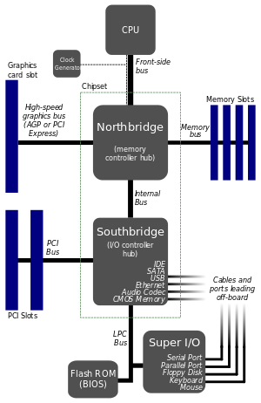

The Switches and Jumpers
- DIP (Dual In-line Package) switches are small electronic switches found on the circuit board that can be turned on or off just like a normal switch. They are very small and so are usually flipped with a pointed object, such as the tip of a screwdriver, a bent paper clip, or a pen top. Take care when cleaning near DIP switches, as some solvents may destroy them. Dip switches are obsolete and you will not find them in modern systems.
- Jumper pins are small protruding pins on the motherboard. A jumper cap or bridge is used to connect or short a pair of jumper pins. When the bridge is connected to any two pins, via a shorting link, it completes the circuit and a certain configuration has been achieved.
- Jumper caps are metal bridges that close an electrical circuit. Typically, a jumper consists of a plastic plug that fits over a pair of protruding pins. Jumpers are sometimes used to configure expansion boards. By placing a jumper plug over a different set of pins, you can change a board's parameters.

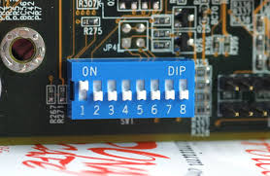

SATA
Stands for, "Serial Advanced Technology Attachment," or "Serial ATA." It is an interface used to connect ATA hard drives to a computer's motherboard. SATA transfer rates start at 150MBps, which is significantly faster than even the fastest 100MBps ATA/100 drives. For this and other reasons, Serial ATA is likely to replace the previous standard, Parallel ATA (PATA), which has been around since the 1980s.
Besides faster transfer rates, the SATA interface has several advantages over the PATA interface. For one, SATA drives each have their own independent bus, so there is no competition for bandwidth like there is with Parallel ATA. They also use smaller, thinner cables, which allows for better airflow inside the computer. SATA cables can be as long as one meter, while PATA cables max out at 40cm. This gives manufacturers more liberty when designing the internal layout of their computers. Finally, Serial ATA uses only 7 conductors, while Parallel ATA uses 40. This means there is less likely to be electromagnetic interference with SATA devices.
In summary, Serial ATA is a better, more efficient interface than the dated PATA standard. If you are looking to buy a computer that will support fast hard drives for years to come, make sure it comes with a SATA interface.
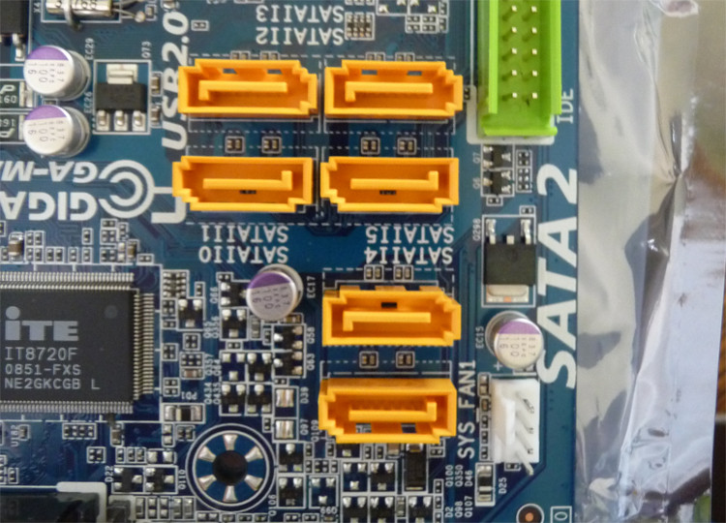

Conclusion: Different parts of motherboard were studied and analysed.

Post Lab questions:

1) How to load default settings of CMOS?
To reset your computers CMOS or BIOS settings:

- Enter CMOS setup
- In CMOS setup, look for an option to reset the CMOS values to the default setting or an option to load the fail-safe defaults. With many CMOS setup screens, there will be a function key to do this. For example, the F5, F6, F9, F11, or F12 key, as shown in the picture, may be set up as a shortcut to load the default settings. Other setups may list an option that you can arrow over to using the arrow keys and pressing Enter.
- When found and selected, you'll likely be asked if you're sure you want to load the defaults. Press Y for yes or arrow to the yes option.
- Once the default values have been set, make sure to Save and Exit and not just exit.

Date: 26/01/2019 Signature of faculty in-charge

